"EDUCATION IS THE MOST POWERFUL WEAPON WHICH YOU CAN USE TO CHANGE THE WORLD."
-NELSON MANDELA-​
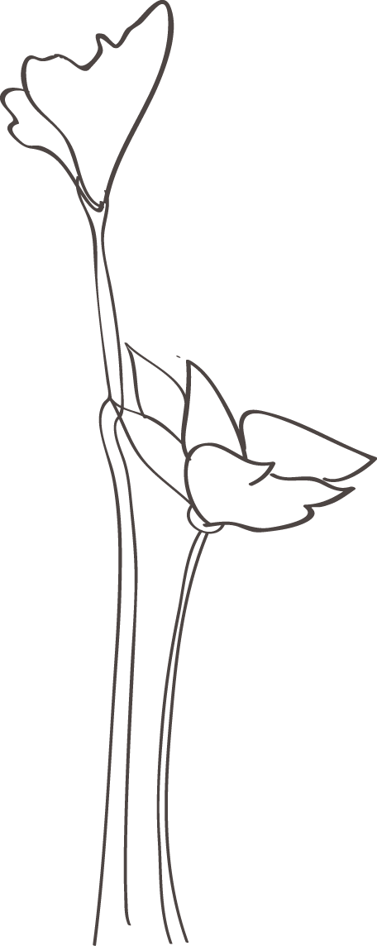
Every child brings his/her own set of unique circumstances, experiences and needs into the classroom. It is imperative for teachers to foster this diversity and meet each individual needs and goals. Learning should be hands-on, authentic, and inquire driven. Students should be allowed many opportunities to learn through cooperative groups with lessons which allow for differentiation and be presented in ways where students develop a love for life-long learning. One of my main goals as a teacher is for my students to feel confident and successful every day. I also believe that learning should be fun. Teachers should help motivate students to learn by trying new and creative ways of teaching. I want my students to come to school ready and excited to learn in my classroom. No one is perfect, but we can always improve by transforming weaknesses into strengths and using our mistakes as learning opportunities. Building a rapport with students and their family’s while creating an open line of communication helps to form a classroom community. Creating a classroom community involves everyone, from the principal, to the students to the parents, to the teacher; which will help to create a positive atmosphere. I believe the classroom is a living community and that everyone must contribute, in order to maintain that positive atmosphere. I believe, wholeheartedly, that students and teachers are both equally receivers and producers of knowledge; I learn from students as much as they learn from me. By modeling respect and kindness, through words and actions, I have extremely high expectations for my students to reciprocate that same respect and kindness.
Samantha Giles

